**LEBANESE AMERICAN UNIVERSITY**

**USAID – HIGHER EDUCATION SCHOLARSHIP PROGRAM**

**HES - Volunteering Program Verification Form**

This form is to be used to document volunteering hours. If a student volunteers for multiple organizations, a separate form must be used for each organization. **This form must be turned in by the 28th of each month, the latest.**

I certify that the scholar Mirella Mekdad completed a total of 2 hours of service at InnovaThrive.

The hours were completed hours as per the below:

Hours # 0 (date) _2/12 – 6/12_ (initials of supervisor) __A.K.___

Hours # 0 (date) _9/12 – 13/12_ (initials of supervisor) __A.K.___

Hours # 2 date) _16/12 – 20/12 (initials of supervisor) __A.K.___

Hours # 0 date) _23/12 - 27/12 (initials of supervisor) __A.K.___

Brief description of the activities the scholar performed or participated in:

I searched for the Blockchain’s Role in Supply Chain Transparency  
  
Definition: How blockchain enhances visibility in supply chains.  
Key Features:  
Immutable records, real-time tracking.  
Real-Life Examples:  
Companies using blockchain for traceability (e.g., De Beers).  
Statistics: Impact on supply chain efficiencies.

Written feedback about the scholar’s performance:

Mirella’s research on blockchain in supply chain transparency emphasized real-time tracking and immutable records. Using De Beers as an example, her work showed how blockchain can improve traceability and efficiency in supply chains.

Please rate the overall performance of the scholar at your organization:

|  |  |  |  |
| --- | --- | --- | --- |
|  | Mastery (5) | Proficient (3) | Emerging (1) |
| **Problem solver** | X |  |  |
| **Engaged & Committed** | X |  |  |
| **Open-minded & multicultural** | X |  |  |

Signature

& stamp

__________________________

_

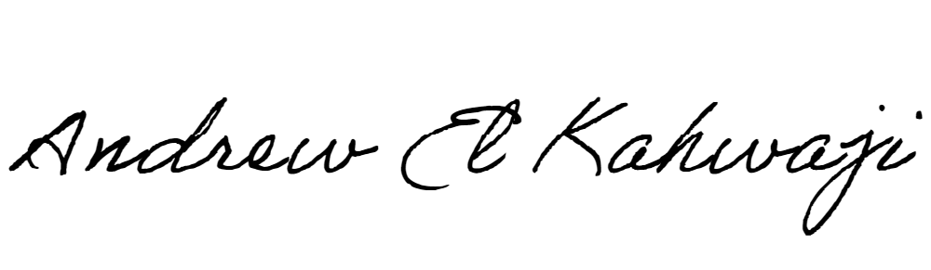

Printed Name _Andrew El Kahwaji_

Date __26/12/2024___

Email __andrew.lifesculptor.coo@gmail.com __

Phone __+961 71 914 378__